Estimating Heights of Trees

Method 1: Pencil and Partner

1) Choose one partner, measure his/her height in metres and record it here: _______________.

2) Have this partner stand at the base of the tree. Standing in front of him/her, hold your pencil straight out in front of you and move slowly away from the tree until the top of the pencil is at the top of your partner’s head, and the bottom of the pencil is at the bottom of your partner’s feet.

3) Next, estimate how many pencil lengths it would take to reach the top of the tree. You can do this by flipping the pencil from end to end, up the tree. Write down that number here:_______________.

4) What will you do with this to determine the height of the tree? Show your work and determine if your answer is reasonable.

5) Switch and do the measurements with the other partner. How does the estimated height differ? Why?

Method 2: Single Person Measure

Native Americans used a different way to estimate the height of a tree; this method uses very little equipment, other than your body!

1) Walk away from your tree and find the place where, when you bend over and look through your legs, you can just see the top of the tree. This may take a few tries! Once you have found this spot, use your tape measure to measure the distance from where you are to the base of the tree in metres. Record it here: __________________________.

2) Next, look at the diagram below. Basically, for the average adult bending over to look through his/her legs, the angle that is formed looking up at the top of the tree is approximately 45 degrees.
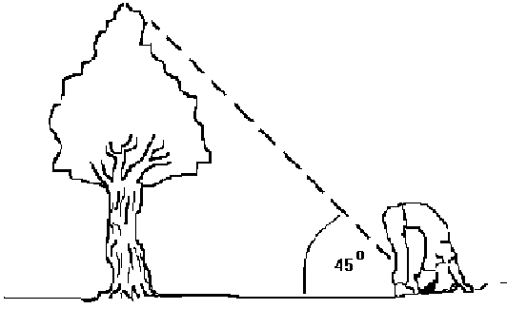

3) Draw a triangle that is represented by you, the tree base and the tree top. Label the angles of the triangle and determine the height of the tree (based on what you know about triangles)

4) Compare the height you determined with your partners. How similar are they? Discuss why they might vary.

Method 3: Shadow Measurements (only works if it’s sunny)
1) Wait until the tree casts a shadow then measure the length of the shadow: ________________.

2) Use a benchmark (your own height, or a meter stick, or a ruler, or anything else short enough for you to measure) and measure the benchmark height: _________________, and its shadow length: ___________. Be sure to do it as soon as you can after you measure the tree shadow!

3) Draw two similar triangles with the measurements you’ve made and use them to determine the height of the tree.

4) How do you know the triangles are similar?

Reflections:

1) How similar were all three of your measurements? Give the range.

2) Which method do you think is the most accurate? Why?

3) What are the pros and cons of each method?

4) Where else could you apply some of these methods?

Based on the information from these two resources:
https://www.mcgill.ca/redpath/files/redpath/Trees.And.Math.pdf
https://nrich.maths.org/2434

